**Tutorial: Media Queries for Responsive Design**

Hello, Today I want to show you how to use media queries in CSS to change the appearance of things based on the width of the computer screen.

**What's a media query?**

A media query is a special rule that allows us to control how styles are applied to elements by using information from the browser, such as the type of screen being used, the format, and the width and height of the screen.

A media query consists of a media type and an expression. I've got a basic page here with a single heading.

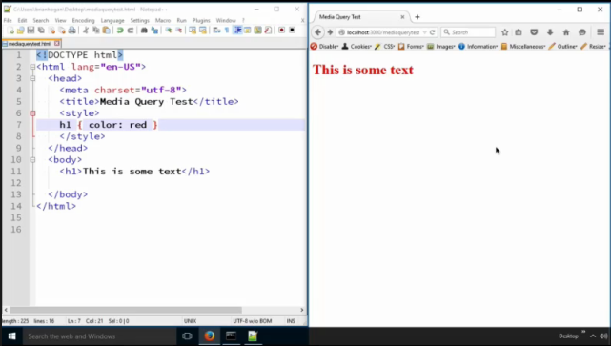

I'm just going to give this text some color with CSS. **Add the following embedded CSS inside the styles tag inside the head tag:**

**h1 {color: red;}**

And now my heading is red.

Now, using media queries, I'm going to change the color of the text based on the size of the screen.

Here's a media query. **Add the following embedded CSS inside the styles tag inside the head tag:**

**@media (min-width: 480px) {**

**}**

This says, “If the screen's minimum width is 480px" then run these rules.

So, let's make the text blue. **Add the following embedded CSS inside the styles tag inside the head tag:**

@media (min-width: 480px) {

**h1 {color: blue;}**

}

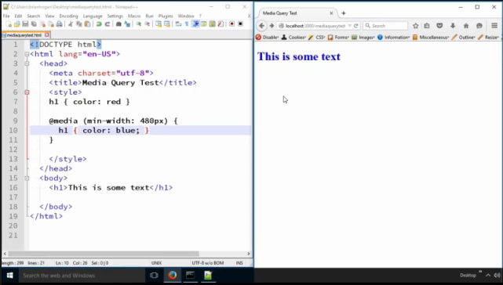

And look! Our text is now blue. But if we shrink that window way down... our red shows up again!

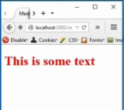

Firefox allows you to view your responsive design without constantly resizing the window.

**On the web page, right click and select “Inspect Element”.**

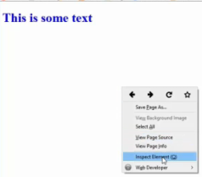

**Click on “Settings” – the**  **symbol.**

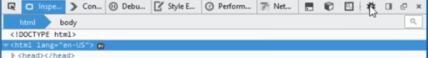

**Ensure that the “Responsive Design Mode” is check-marked.**

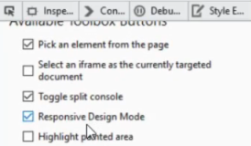

If the “Responsive Design Mode” is checked, you will see the following icon:



**Click on the**  **icon.**

This will bring up the responsive design view. **Close the console window at the bottom of the page.**

It now should look like the image below:

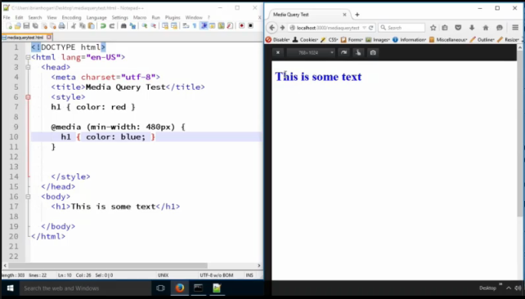

**Note:** Notice the display settings at the top of the document. You can switch display views.

Let's do another one. **Add the following embedded CSS inside the styles tag inside the head tag:**

**@media (min-width: 767px) {**

**h1{color: green;}**

**}**

After you choose a wider screen size at the top of your display window you will see the following green text:

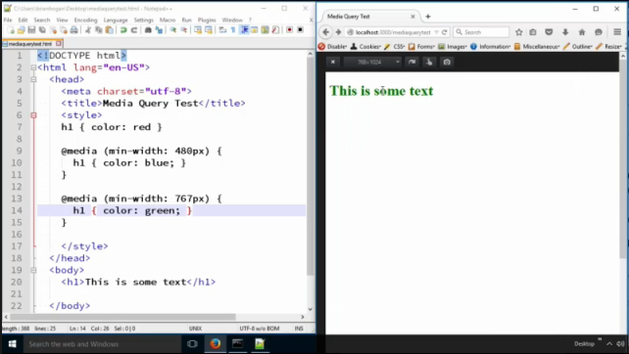

If we shrink the display settings down a bit, we will see blue text:

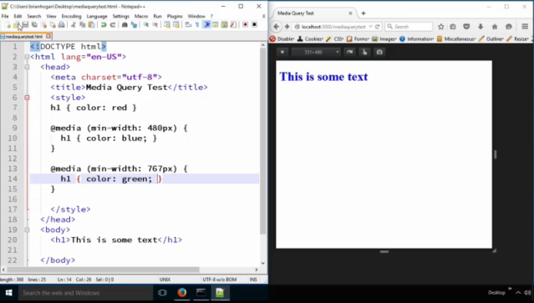

If we shrink the display settings down all the way, we will see red text:

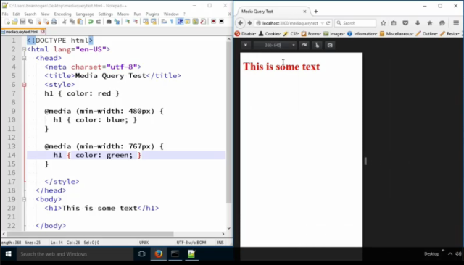

Right now, we've been using "min-width". But we can also use "max-width". What if we wanted the h1 text to be smaller on screens smaller than 768px? We could do that like shown below. **Add the following embedded CSS inside the styles tag inside the head tag:**

**@media (max-width: 767px) {**

**h1{font-size: 20px}**

**}**

And when we look, sure enough, it's small! On the small screens, the text is 20px and on the larger screens it is larger text.

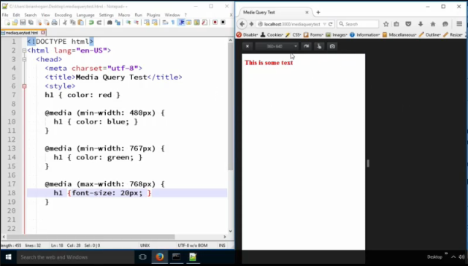

We can also target specific ranges.

What if, when the page is between 768px wide and 960px wide, we wanted to make the text on the page centered?

Easy! **Add the following embedded CSS inside the styles tag inside the head tag:**

**@media (min-width: 768px) and (max-width: 959px) {**

**body {**

**text-align: center;**

**}**

**}**

Now, it's only centered in that range.

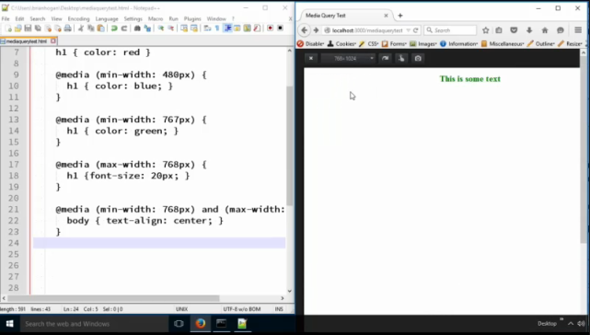

The media rules in a stylesheet only activate when the rule's conditions are met. You do need to be careful though - the rules of specificity and order still come into play here.

Study this example and see if you can come up with some examples of your own to practice. Media queries are incredibly important to providing experiences across multiple devices, which is what we'll discuss next.

Below is the final HTML and CSS:

<!DOCTYPE html>

<html lang="en-US">

<head>

<meta charset="utf-8">

<title>Media Query Test</title>

<link rel="stylesheet" href="[stylesheets/style.css](view-source:file:///C:/Users/kloewenhagen/OneDrive/School/WEB1/Lessons/lesson6/stylesheets/style.css)">

<style>

h1 {

color: red;

}

@media ( min-width: 480px) {

h1 {

color: blue;

}

}

@media (min-width: 767px) {

h1 { color: green; }

}

@media (max-width: 767px) {

h1 { font-size: 20px; }

}

@media (min-width: 767px) and (max-width: 959px) {

body { text-align: center }

}

</style>

</head>

<body>

<h1>This is some text</h1>

</body>

</html>